The Holidays in Greece
- In Greece when we talk about the "holidays" we are referring to the holiday period of Christmas, New Year and Epiphany.

Christmas
- Traditionally the Christmas holiday period lasts 12 days in Greece. Store windows are decorated almost a month in advance, and in the cities the streets and town squares are lit with colourful lights. In Greece, a fasting period would start almost 40 days before Christmas mostly for religious, but also for health reasons. People then would not eat meat or its related products, i.e. dairy or eggs.
- The name days of Manolis or Emanuel or Manos or Emanuela are all celebrated on Christmas Day, and friends and relatives will stop by to wish them "many happy returns" or "hronia pola".
- Houses would be cleaned with extra care, and a few days before Christmas housewives would prepare the Christmas cookies; the honey cookies (melomakarona) were made exclusively for Christmas, while sugar cookies (kourabiedes), were prepared for the New Year. Today, though, both melomakarona and kourabiedes are prepared and consumed during the Christmas and New Year holidays period.
Christopsomo is the bread that is made on Christmas Eve, which has a cross carved into the top crust before it is baked. On Christmas Day, the head of the household makes the sign of the cross above the loaf of bread, cuts it and gives a piece to each person at the dining table.

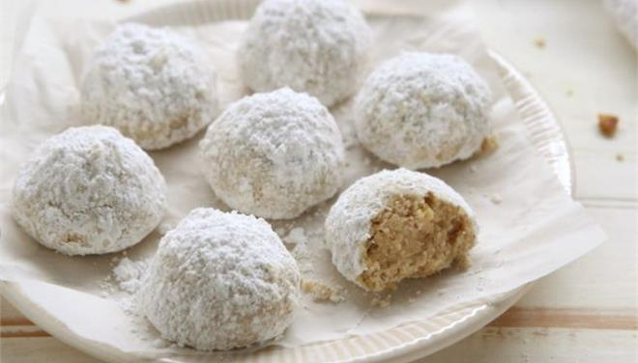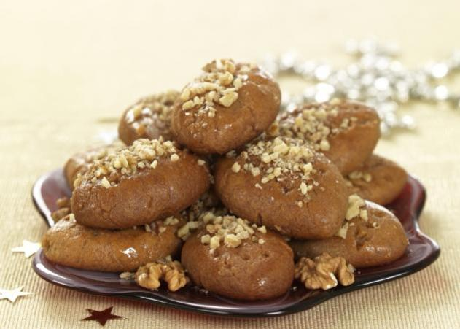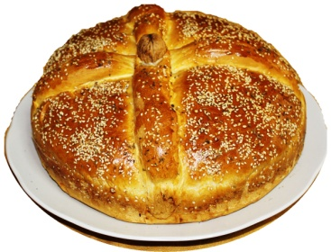

kourabiedes melomakarona christopsomo
- In older times in Crete it was the custom for each family in the village to raise a pig, or "hog" (hiros in Greek), which would served as the main holiday dish on Chrisimas day. The custom of the turkey for Christmas is now widely used in Greece and has almost replaced the pork meat for holiday fare - but not completely.
- Today almost everyone decorates a Christmas tree in Greece, real or artificial. Usually they are decorated a few days before Christmas and remain in the homes until Epiphany. In older times, this custom did not exist in Crete and in some other parts of Greece they would decorate little boats instead.
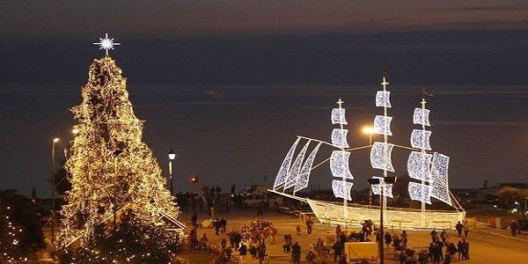

Kalikanztaroi, The Greek Christmas Sprites
Kalikantzaroi, or the Greek Christmas Sprites, are small blackish and hairy creatures, with long arms and tail, who reside in the bowels of the earth, friendly but troublesome little creatures; they surface on Earth only during the 12-day period from Christmas to the Epiphany (January 6). According to the Greek legend, these creatures’ origin is the centre of the earth, where their mission is to chop at a huge tree trunk symbolising the earth's foundations. While on Earth, they love to hide in people's houses slipping down the chimney. Being extremely naughty, the “kallikántzari” do things to frighten people, like overturning furniture, devouring Christmas foods, or contaminating the water. Throughout Greece, numerous rituals are performed to keep these hobgoblins away. In some places mothers sprinkle holy water in every room of the house to scare the “kallikántzari” away.

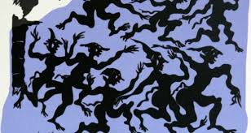

New Year in Greece
- In Greece it is the custom to exchange gifts on the New Year instead of Christmas. The presents are delivered by Saint Basil (Agios Vasilis). Agios Vasilis is the Greek Santa Claus
- On New Year's Eve everyone gathers around waiting for the vasilopita (the new year's cake with a coin hidden inside) to be cut as the new year rolls in. When the time comes the mother starts to cut the cake. The first piece is for Christ, the second for the house, and then pieces for everyone present. The one who gets the piece with the coin will be the lucky one of the year!

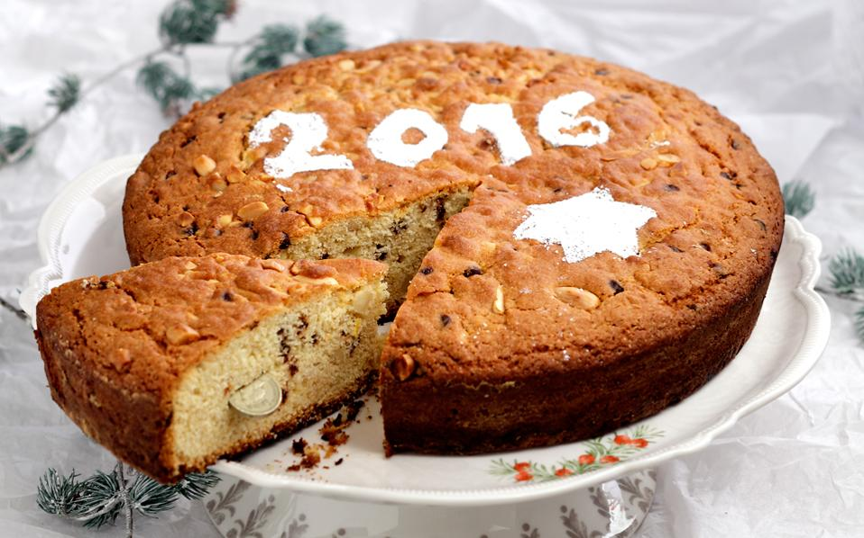

- Because Greeks consider the New Year lucky, it is the custom to participate in games of chance on the first day. In addition to the state lottery which raffles 10 million euros on New Year's Day, people play cards and roll dice in coffeehouses, clubhouses and homes throughout the country.

- Many people believe in the good/bad omen regarding who will first enter their home in the new year ( pothariko). On New Year's Eve they will ask a close friend or relative, whom they consider lucky, to be the first to come into their house the following day. Often, a child is preferred for this special practice because children are considered innocent and their hearts free of malice and envy.
- It is the custom for money (kali hera) to be given to children visiting on New Year's day - usually grandchildren or nieces and nephews.
- The Squill is a common plant in Crete , which grows wild and looks like a large onion. Even when pulled from the soil, it continues to bloom and produce new leaves. People believe that it means good luck for the house and for this reason a sea onion would hang in the home at the New Year.
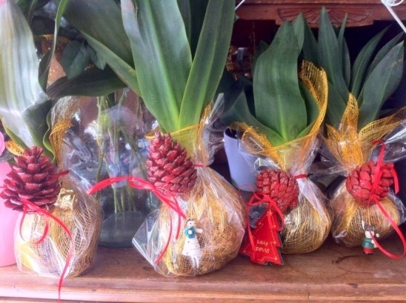

Epiphany
- On the sixth of January, the Christmas holidays in Greece officially come to an end with the 'festival of light' ('ton foton' in Greek), also known as Epiphany. On Epiphany, the Greek Orthodox Church performs the 'Great Blessing of the Waters'. This ceremony is usually performed twice, once on the eve of Epiphany which is performed in the church, and then again on the actual day outdoors with priests blessing water, sea, rivers, lakes etc.
The tradition is that a priest, surrounded by brave young men and boys, throws a cross into the sea, either from the harbour or from a boat at sea; the minute the cross leaves the priest’s hand, the divers jump into the freezing water to catch the cross. The lucky one who finds and returns the cross is blessed by the priest. As the cross is victoriously brought back, the priest releases a white dove, as a symbol of the holy spirit. This tradition is carried out to remind us the baptism of Christ and to bless the waters. . Afterwards, the priest goes from house to house holding a cross and a basil branch. As he walks through each house, he uses the basil to sprinkle (bless) all the areas of the home.
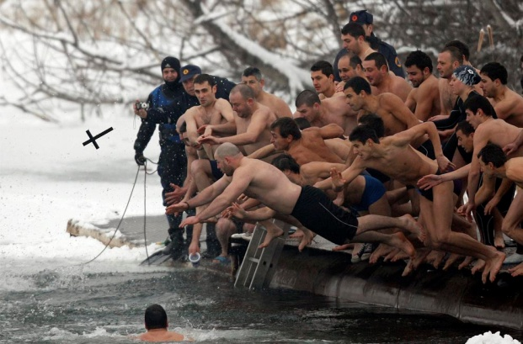

Christmas Carols , New Year and Epiphany Carols
A very old custom which remains today practically unchanged is the Greek Christmas carols, which is called calanda in Greek. Children, in groups of two or more, still make the rounds of houses singing carols, usually accompanied by the triangle or guitars, accordions or harmonicas.
The children go from house to house, knock on doors and ask: "shall we say them?" If the homeowner's answer is yes, the kids sing the Christmas carols for several minutes before finishing up with the wish, "And for the next year, many happy returns." Years ago the homeowners offered the children holiday sweets and pastries, but today they usually give them some money.
The carols are sung on the eves of Christmas, New Year and Epiphany, and they are different for each holiday.

You can enjoy Greek carols on the following links:
Christmas carols: https://www.youtube.com/watch?v=bHON9Wg9cK8
New Year's carols: https://www.youtube.com/watch?v=VYBvOTNAH5M
Epiphany carols: https://www.youtube.com/watch?v=A8t4YwJs4LM
Cretan carols: https://www.youtube.com/watch?v=rvaTFwRNVNA
